Verbal and Nonverbal Violence in Broadcast Channels Influencing Viewer's Behaviour.

Abstract
The purpose of this study is to examine the prevalence and impact of verbal and nonverbal violence in broadcast media and analyse its psychological, societal, and behavioural consequences. People watch broadcast channels to stay updated, whether on sports, war, or the most popular niche, National and International politics. Politics is a consequential matter in a world where humour is hilarious. In these situations, verbal violence takes the form of angry conversations and black humour, which shapes viewers' opinions and feeds prejudices. This research paper explores the blurring lines between the two: where the humour gets too far by representing politics humorously and humour that can be dark and have profound implications. It is a form of satire that conveys criticism against the political status quo in a humorous way and/or confirms dominant perspectives on politics by recycling and reinforcing them. This research paper explores the theoretical frameworks for the practicalities of verbal violence that manifests in the use of humour during political debates on Television. In context, this paper aims to confront the extensively received presupposition that the viewer is only a listener. The study highlights viewers' active engagement in interpreting meanings delivered during televised debates, challenging the notion that viewers are passive recipients. The political debates involve dialogue among participants and, if not primarily, the exchange of meanings they want to convey to the listeners. Politicians can simultaneously use verbal aggression with two types of general audiences: to disaffiliate from the conversationalist and entertain and foster cohesion with their listeners. The study recommends stricter regulations, additional media accountability measures, and educational initiatives to mitigate the negative effects of verbally violent content on individuals and society as a whole
Keywords- Verbal-violence, nonverbal Violence, Broadcast media, Politics, dark humour, political satire

Introduction
The foundation of moral news reporting is the idea of impartiality, fairness, and inclusivity. By providing a variety of perspectives and forming narratives, media professionals—especially those in television and video—have a big impact on public opinion. This duty becomes much more important when dealing with controversial or polarising topics. In order to promote balanced conversation, writers and broadcasters must ensure that their methods are informed by inclusivity and reason.
In particular, media employees in television and video have the power to influence their audiences by compelling arguments for the need to conduct fair, normal, and calm investigations of issues and make thoughtful choices regarding various viewpoints, especially in cases where opinions are disagreeable or critical. It is the responsibility of writers to ensure inclusion and levelheadedness guide their approach in building a prevailing account..There has been an aggravating slant with writers and certain media channels depicting the divided scope of issues, frequently focusing on Indians with slur and shame over the past decade. The devout minorities of India find themselves at the heart of this developing design. An uncontroversial aspect of this advancement is that it also has capable political endorsement, given the preferences of the administering allotment. Not as it were new organisations, established to supply the open with an unbiased and honest picture of the world, wavering in their tries, but person writers and grapples have ended up wrongdoers.
Social concordance and majority rule government are debilitated when personal partiality, deception, and injustice penetrate how "information" is depicted in broadcast media. Controlling the relating of occurrences or sees that are not intelligent of all actualities, as well as spreading untrue data and generalisations vis a vis different populaces, undermines the certainty that the open places within the media. The media is entrusted with a grave duty in advancing the voice and representations (through issues and news) of all segments of the populace. Over about a decade, an aggravating and inconvenient improvement uncovers a media that has become more communalised, with the exemption of a few papers and journals and a couple of broadcast channels.
In order to elicit strong feelings from viewers, broadcast media outlets have been using split-screen and dramatised images. Although these techniques can successfully draw attention, they frequently conflate sensationalism with factual reporting, strengthening societal differences and encouraging group biases. While promoting increased accountability and moral behaviour in the sector, this study aims to address the detrimental psychological, social, and behavioural effects of verbal and nonverbal violence in broadcast media.

Research Objectives
- To examine how employment of verbal and nonverbal violence negatively influences an individual’s psychology, thought processes, and beliefs.
- To examine why verbal and nonviolence attract audience or listeners.
- To scrutinise the role of Broadcast media channels that serve as a source of enabling hate speech and discrimination.
- To demonstrate and explain through quantitative and qualitative research how verbal and nonverbal violence manifests into real hatred and discrimination.

Review of Literature
(Maria Florea, 2018) The broadcast media plays a salient role in caring viewer’s perception, determining behaviors, and even fostering symbolic violence through persuasive and manipulative techniques. Research highlights how advancements in communication technology have amplified these effects, particularly through nonverbal cues, selective imagery, and misinformation Political manipulation, as seen in digital election interference, demonstrates media's potential to alter democratic outcomes. Fear-mongering through crime and health narratives further affects societal anxieties and decision-making. Children, particularly susceptible to advertising, often fall prey to persuasive marketing, impacting their consumption habits. Symbolic violence within media narratives reinforces ideological constructs, while disinformation campaigns distort reality, complicating public understanding. Despite extensive studies, gaps remain in understanding the long-term psychological impact of media exposure, necessitating further interdisciplinary research to navigate the evolving digital landscape and its influence on society.

Mediated noise, a growing concern in socio-political discourse, shapes public engagement through high-decibel debates, misinformation, and stylistic disruptions in broadcast media. The spread of "fake news" further amplifies this noise, distorting political narratives and public understanding. Beyond politics, noise also affects public health perceptions, influencing behaviors through media portrayals, such as sensationalist health coverage and social phenomena like "mukbang". Theoretical models highlight how noise operates within neoliberal media practices and technical communication systems. However, gaps remain in understanding noise’s demographic impact and its role beyond politics and health, warranting further research into its effects on civic engagement, environmental discourse, and social justice movements. As media evolves, so does the need to critically assess noise’s influence on public perception and democratic participation.

Empirical Studies

Such research studies identified several radio channels to demonstrate most verbal and nonverbal violent media content that maintains hate speech, violence, and aggression among audiences. It is supported by empirical data to determine whether regular exposure to verbal and nonverbal violence in radio-media channels leads to desensitisation to violence. A study conducted by Siddharth Narrian and Tanishka Maurya found empirical evidence by examining how the Indian court deals with hate speech and focuses on whether it directly stimulates public dysfunction. In cases like Akbaruddin Owaisi or Amish Devgan, the court decided that speech was controversial, but did not lead to immediate force. However, philosopher Jeremy Waldron argues that hate speech goes beyond incitement and should consider the lasting damage to the dignity and security of marginalised communities. India's hate speech laws such as IPC Sections 153A and 295A aim to prevent tensions in municipalities but have been abused to silence artists, journalists, and dissenting opinions, as seen in the Arnavgoswami case. The Law Commission 2017 report proposed expanding the law to cover speeches that fear and deepen social division. Other countries, such as Australia (Victoria), are tightening legislation to protect groups that need protection against hate-oriented rhetoric. The case of Shreya Singhal (2015) confirmed that only speeches from agitating should be illegal, while reports such as hatred wages highlight the deeper impact of defamation. "How can we protect freedom of speech and ensure that our community is not affected by hatred or discrimination?”

Research Methodology

Research Design

Only a few research studies have been conducted on the positive relationship between verbal and nonverbal violencehate speech and aggressive behaviour in youngsters and adults. Nevertheless, this research paper adopts a mixed-method approach, reinforcing both profound Primary and Secondary data to comprehensively analyse the impact of graphic murders in the Entertainment Industry. Given the limited availability of secondary data on the selected topic, the primary data will compensate to fill the research gaps and provide significant insights on the selected topic.

Type of Data

In this research both Primary and Secondary data have been used, the Secondary data has been collected from viable research projects, newsletters, and articles while the Primary data has been collected from the regular viewers of broadcast media viewers and listeners through a survey to directly collect the empirical data for the research purpose.

Primary Data: The Primary data for this research has been collected through a questionnaire circulated among the regular broadcast media channel viewers. Their valuable insights will help us to examine the correlation between the depiction of hate speech and graphic violence, analysing its behavioral influence on young and adult viewers.

Secondary Data: Secondary data is collected through the available academic articles, reports, news reports, and media studies covering verbal and nonverbal violent aspects in the Broadcast media channels. Data will be analysed to contextualise and support the findings from Primary data obtained for the research. The limited scope of secondary data on this topic necessitates a stronger reliance on primary research findings.

Source of Primary data
The sample size for the research is 32 regular viewers of movies and series. Stratified random sampling has been used to ensure inclusion of demographic diversity such as age, and gender which were subjective to the respondents. A questionnaire is used to survey the research study, analyse the respondents' insightful responses, and support the research study.
The questionnaire is categorised as:
Open-ended Questions: Open-ended questions allowed respondents to answer subjective questions such as age and gender
Multiple Choice Questions: The survey has multiple choice questions, and respondents were open to choosing the best possible option that resonates with them.
Likert Scale: The survey also included Likert scale items measuring emotional responses, attitude towards violence, and behavior post-exposure to graphic murders and violence in the entertainment media.

Significance of the Study

- This study looks at how viewers' emotions, thoughts, and behavior—including possible desensitisation—are impacted by verbal and nonverbal violence in broadcast media.

2. This study offers new insights by addressing a research gap that frequently generalises media violence by concentrating on verbal and nonverbal violence.

3. The results will aid scholars, media experts, and educators in comprehending how audiences are affected by violent speech and imagery.

4. This study will demonstrate how individual differences influence reactions to violence in the media by examining various age and gender groups.

5. Evidence about whether frequent exposure to violent media diminishes empathy or normalises hostility in society will be presented.

Hypothesis
H1. Desensitisation to aggressiveness and conflict in the actual world is brought on by exposure to verbal and nonverbal violence in broadcast media.

H2. People who watch a lot of violent debates, violent conversations, and unpleasant interactions in the media are more inclined to act aggressively and confrontational in real life.

H3. Regular media exposure to verbally and nonverbal violent content is linked to a decreased capacity for empathy towards those impacted by actual hostility and aggressiveness.

H4. Compared to older adults, children, and teenagers are more susceptible to the behavioral and psychological repercussions of verbal and nonverbal violence in the media.

H5. Gender differences may exist in the emotional reactions to violent media discourse, with men expressing less distress than women when exposed to hostile or aggressive communication.

Data Analysis
1. What is your age?
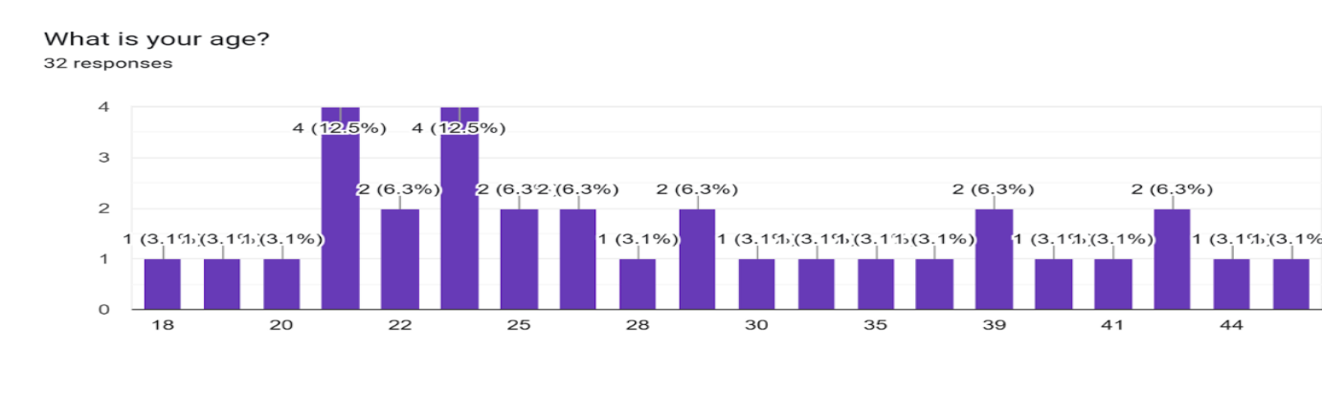
The age distribution of the 32 survey participants (18–44 years old) is shown in the bar chart. With four responders each (12.5%), age groups 20 and 22 represent the most. Only one responder (3.1%) is present in several age categories (18, 19, 23, 25, 28, 30, 35, 41, and 44). Two people (6.3% each) responded to groups 24, 29, and 39.

The sample is younger, with half of the respondents (50%) between the ages of 20 and 25. Ages 30 and older had far lower representation, each contributing less than 6.5%, indicating a bias toward younger people.
- What is your gender?
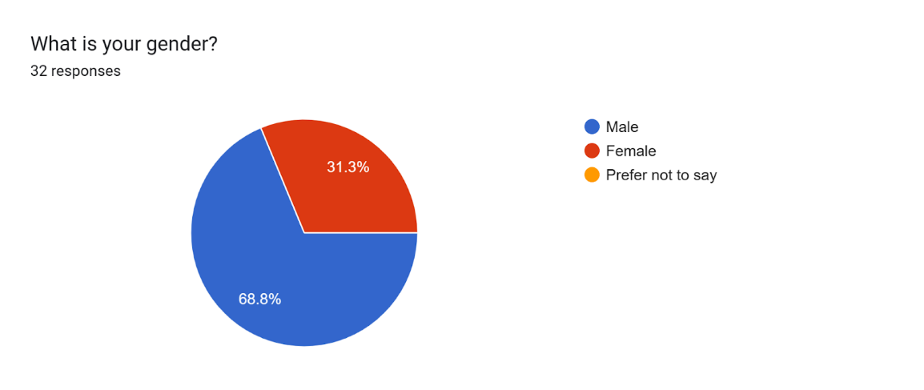.
The pie chart illustrates the gender distribution of 32 survey respondents, revealing a significant disparity. Males constitute 68.8% of the sample, while female respondents comprise only 31.3%, highlighting an imbalanced representation. With males being more than twice as prevalent as females, the data suggests a demographic skew, which may impact the overall findings depending on the survey's context.

- Do you believe there is a correlation between verbal and nonverbal violence on broadcast media which contributes to rising crime and violence in society?
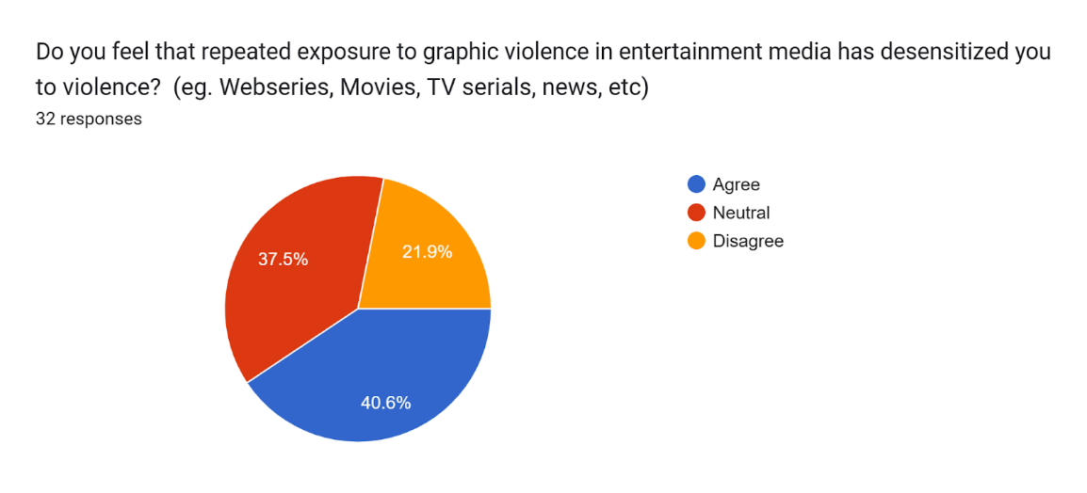
32 participants' answers about whether or not repeated exposure to graphic violence has desensitised them are displayed in a pie chart. Of them, 37.5% (12 respondents) are neutral, 21.9% (7 respondents) disagree, and 40.6% (13 respondents) agree that it has a desensitising impact.

Of the male respondents (22), 22.7% disagree, 45.5% are unsure, and 31.8% feel desensitised. Of the 10 female responses, 30% do not feel desensitised, 20% are unsure, and 50% agree.

Of the 16 younger respondents, 6.38% feel desensitised, 6.38% are undecided, and 4.25% disagree, according to the age group. Of the eight middle-aged respondents, 2.25% disagree, 3.38% are unsure, and 3.38% agree. 7.88% of the 8 older respondents say they are desensitised, whilst 1.12% are unsure.

- What do you think is the primary motive of verbal and nonverbal violence content on broadcast media channels?
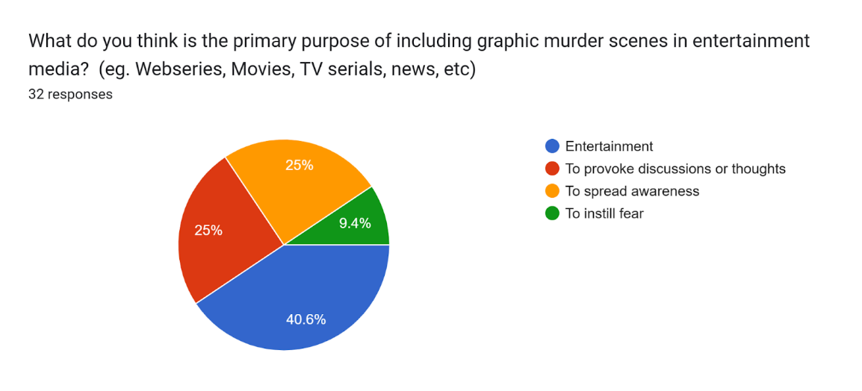
The pie chart illustrates the responses of 32 participants regarding the primary purpose of graphic murder content in media. Entertainment was the most frequently given answer (40.6%), followed by raising awareness (25%), encouraging conversation or thought (25%), and arousing fear (9.4%).

Of the males (22 respondents), 36.4% said it was mostly for entertainment, 27.3% thought it was to raise awareness, 22.7% thought it sparked thought, and 13.6% thought it was for terror. Ten female respondents were more likely to think that the content was thought-provoking (50%) than to think that it was promoting awareness (20%), entertaining (20%), or frightening (10%). While older respondents (50%) felt it thought-provoking, younger respondents (50%) mostly connected it to amusement. The view of such content as entertainment varied by gender and age, with men (57%) being substantially more likely than women (9%).
- What cohort of individuals are more susceptible to the detrimental effects of verbal and nonverbal violence on broadcast media channels?
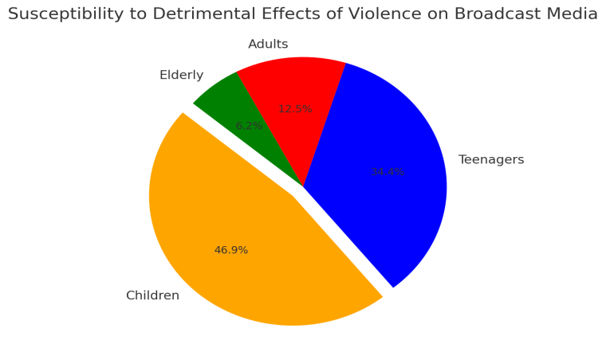
•Children: 46.9%
•Teenagers: 34.4%
•Adults: 12.5%
•Elderly: 6.2%
•
The pie chart illustrates the responses of 32 participants on which age group is most vulnerable to verbal and nonverbal violence in broadcast media. The majority recognised children as the most impacted group, 46.9% (15 respondents), followed by teenagers, 34.4% (11 respondents). Adults were deemed vulnerable by only 12.5% (4 respondents), whereas the elderly were cited by 6.2% (2 respondents).
The majority of female respondents (70%) cited children as the most vulnerable, while male respondents were split between children (36%) and teenagers (36%). While older respondents also tended to favor children as the most affected group, younger and middle-aged respondents largely agreed on children's susceptibility. The findings highlight the widespread belief that children and teenagers are the most susceptible to violent media exposure, emphasising the need for content regulation and parental oversight.

- What impact can the exposure to verbal and nonverbal violence on broadcast media have on an individual in particular and society at large?
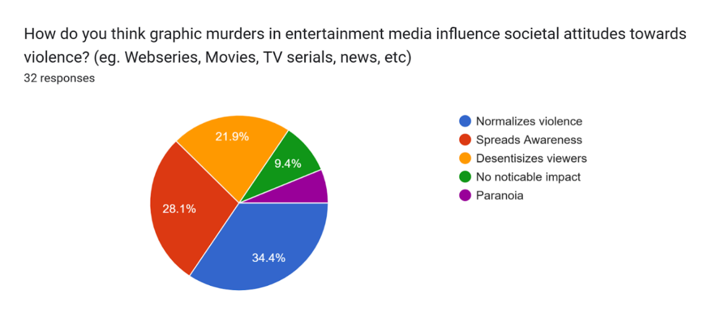

The opinions of 32 respondents regarding the effects of verbal and nonverbal violent content in media are shown in the pie chart. While 28.1% perceive it as raising awareness, the majority, 34.4%, think it normalises verbal and nonverbal violence. About 6.2% link it to paranoia, 9.4% see no effect, and 21.9% believe it desensitises viewers.
There are clear gender disparities: 36% of men and 50% of women think it normalises hatred. However, no female respondents agreed with the 32% of men who believe it desensitises viewers. While middle-aged respondents perceived it as increasing awareness, younger participants associated it with normalisation and desensitisation. Opinions among older respondents were divided. The results show that perceptions differ according to age and gender.

- Have you experienced any change in your behavior after consuming such verbal and nonverbal content on broadcast media?
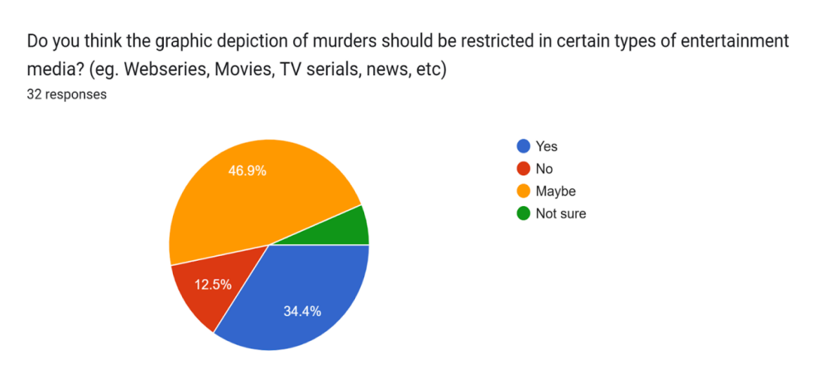
32 participants' answers regarding whether or not watching verbal and nonverbal violent broadcast media has changed their behavior are displayed in the pie chart. Uncertainty was expressed by nearly half (46.9%) who answered "Maybe," and a change was acknowledged by 34.4% ("Yes"). 6.2% were doubtful, and a smaller percentage (12.5%) perceived no influence ("No").
Of the men, 14% disagreed, 36% were undecided, 36% reported behavioral changes, and 9% were unsure. 20% of females reported changes, 70% were unsure, and 10% saw no change. Between "Yes" and "Maybe," younger respondents were evenly divided, whereas middle-aged and older participants tended towards ambiguity or acceptance of change.
Overall, the responses indicate that many people are still uncertain about the influence of the broadcast media, even though some people are aware of behavioral changes.

- Do you think broadcast media channels and journalists should be held responsible for the glorification and perpetuation of verbally and nonverbally violent content and real-life violence on their platforms?
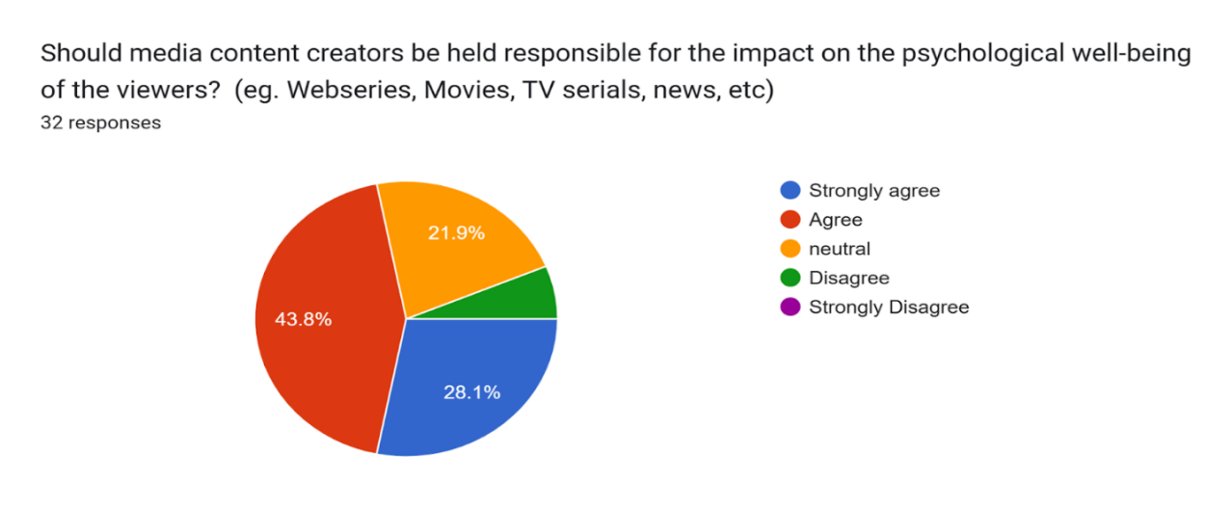
32 participants' answers regarding whether journalists and broadcast media channels should be held responsible for using onscreen verbal and nonverbal violent content are displayed in the pie chart.
14 respondents, or 43.8%, agree that journalists and broadcast media channels should be held accountable; Nine respondents, or 28.1%, strongly agree; Seven respondents, or 21.9%, are neutral; 2. Respondents disagree or strongly disagree, making up 6.2%. Of the 22 male respondents, 14% strongly agree, 14% are ambivalent, and 45% agree. Of the ten female respondents, 10% are neutral, 40% agree, and 40% strongly agree. Most younger respondents (18–24) lean towards neutrality or agreement. Older respondents (41–45) and middle-aged (25–40) are more supportive of media accountability.
- Do warning labels, violence ratings, and age restrictions address the proliferation and intensity of rising verbally and non-verbally violent content and real-life violence on broadcast media in society?
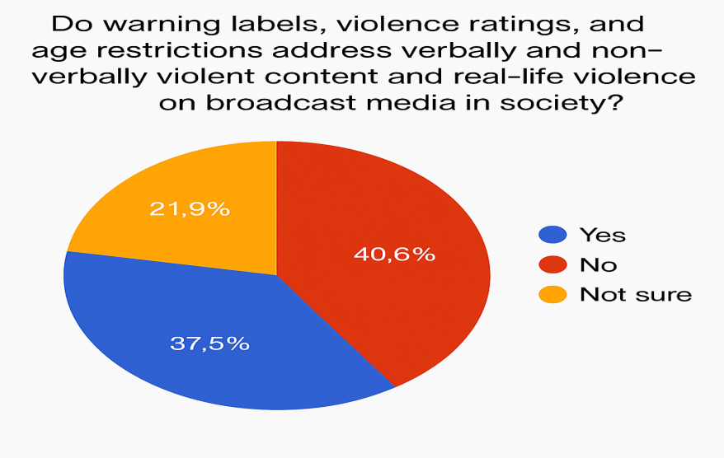
32 respondents to the survey indicated a significant inclination to blame journalists and broadcast media for spreading verbal and non-verb violent content. Just 6.2% of respondents disagreed with this position, 21.9% were neutral, whilst 43.8% agreed and 28.1% strongly agreed.
In contrast to male respondents, who agreed 45% of the time, 14% strongly agreed, and 14% were neutral, female respondents demonstrated greater support (40% strongly agree and 40% agree). In terms of age, middle-aged (25–40) and older participants (41–45) showed greater support for media responsibility, whereas younger respondents (18–24) tended to trend towards neutrality or moderate agreement. According to this research, there is broad support for broadcast media accountability, with significant differences in age and gender.
- What measures do you think can be taken to reduce the negative impact of verbal and nonverbal violence on broadcast platforms?
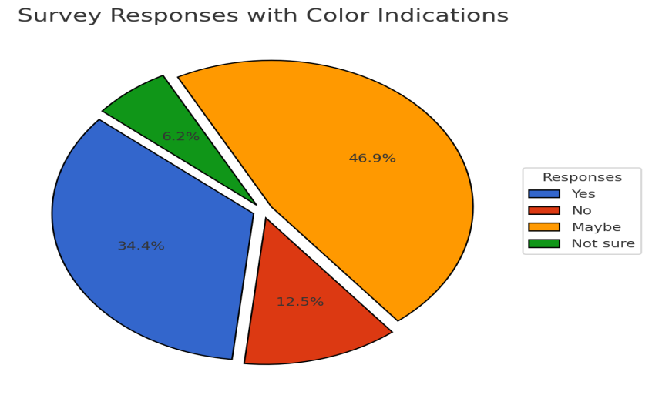

According to a survey of thirty-two people, there is broad support for holding broadcast media and journalists responsible for disseminating verbal and nonverbal violent content. Media accountability was favored by 71.9% of respondents, of whom 43.8% agreed and 28.1% strongly agreed. In contrast, just 6.2% disagreed, and 21.9% were neutral.
With 40% strongly agreeing and 40% agreeing, female respondents demonstrated greater support than male respondents. Of the male respondents, 14% were neutral, 14% strongly agreed, and 45% agreed. Younger respondents (18–24) tended towards neutrality or moderate agreement, whereas middle-aged (25–40) and older participants (41–45) were more likely to favor media accountability.
The results show widespread agreement regarding the necessity of media responsibility, with views on the matter being influenced by age and gender.

FINDINGS AND SUGGESTIONS
Findings
1. Distribution of Ages
Younger respondents Predominate: There is a majority of younger participants, as half of the respondents (50%) are between the ages of 20 and 25. Older age groups (30 and over) are under-represented, making up less than 6.5 percent of the total.

Under-represented Categories: The lack of representation (3.1%) for some age groups (e.g., 18, 19, 23, 25, etc.) restricts the range of views

- Distribution of Gender
Gender Inequality: Of the respondents, 68.8% are men and only 31.3% are women. This disparity could distort the results, especially in fields where gender affects perceptions.

- Diverse Views on Desensitisation to Violence: Although 40.6% believe that viewers get desensitised to verbal and nonverbal violence after repeated exposure, 37.5% are neutral, and 21.9% disagree.
Gender Differences: Compared to men (31.8%), women (50%) are more inclined to agree with desensitisation.
Age Differences: Compared to middle-aged or older participants, younger respondents are more likely to link graphic violence to desensitisation.
- Entertainment is the Main Goal of Violent Content: According to the majority (40.6%), entertainment is the main goal of verbal and nonverbal content, followed by awareness-raising (25%) and thought-provoking (25%).
Gender Perspectives: While women perceive violent content as thought-provoking (50%) and men as entertainment (57%), males are more inclined to regard it as entertainment.

5. Vulnerable to Abuse
Most Affected: According to the majority (46.9%), children are most at risk from exposure to verbal and nonverbal violence, followed by teenagers (34.4%). The elderly and adults are thought to be less vulnerable.
Gender Trends: While male respondents are evenly divided between children and teenagers, female respondents largely name children as the most vulnerable group (70%) in their responses.

6. Effects of Verbal and Nonverbal Abuse
Normalisation vs. Awareness: Only 28.1% of respondents say verbal and nonverbal violence increases awareness, whilst 34.4% think it normalises violence.

Gender Differences: Men's reactions vary, but women are more likely to think it normalises violence (50%).

7. Changes in Behaviour
Uncertainty Predominates: Of those surveyed, 34.4% acknowledged changes ("Yes") in their behavior, while almost half (46.9%) said they were unsure ("Maybe") whether violent media had affected them.

Gender Differences: Although men reported behavioral changes similarly, women are more unsure (70%) than men (36%).

8. Accountability of the Broadcast Media Channels:
Most respondents support Accountability: 71.9% of respondents support making the broadcast media channels responsible for verbal and nonverbal violent content, with women more strongly supporting this idea than men.

Suggestions
- Diversify the demographics of the sample.
To guarantee a wider diversity of viewpoints, future surveys should balance gender representation and include more respondents from older age groups.
2. Encourage media literacy
Create media literacy-focused educational initiatives to assist viewers in evaluating violent content critically and its possible influence on behavior and social norms.
3. Make Content Regulation Stronger
Encourage the implementation of more stringent content regulation laws, such as warning labels, age limits, and violence ratings, particularly for material aimed at children and teenagers.
4. Promote parental supervision
Give parents the tools they need to keep an eye on and control their kids' exposure to verbal and nonverbal violent broadcast media, stressing the value of parental supervision in reducing harmful impacts.
5. Carry Out Longitudinal Research
To learn more about the societal effects of violent media use, examine the long-term behavioral changes that occur in people of all ages and genders.
6. Media should be Answerable
Encourage journalists and broadcasters to take more responsibility for selecting content and refrain from glorifying or needlessly including graphic violence.

Conclusion
Significant insights into how people view graphic violence in broadcast media are provided by the survey data, which also shows a demographic bias in favor of younger and predominately male respondents. A significant number of participants (40.6%) think that watching such a video desensitises viewers, and many of them see it more as amusement (40.6%) than as a way to increase awareness. Since children and teenagers are thought to be the most susceptible to the negative impacts of violent media, content regulation, and parental supervision are critically needed.

Furthermore, there is broad support (71.9%) for holding media companies responsible for how they depict nonverbal violence, with significant variations in opinions according to gender and age. The results point to the urgent need for ethical media standards to lessen the detrimental effects of verbal and nonverbal violent content on viewers.

Works Cited
- Archer, Dawn. 2008. “Verbal aggression and impoliteness: Related or synonymous?” In Impoliteness in Language: Studies on its Interplay with Power in Theory and Practice [Language, Power and Social Process 21], Derek Bousfield and Miriam Locher (eds), 181–207. Berlin/New York: Mouton de Gruyter.
2.Attardo, Salvatore. 1994. Linguistic Theories of Humour [Humour Research 1]. Berlin/New York: Mouton de Gruyter.
3. Beebe, Leslie. 1995. “Polite fictions: Instrumental rudeness as pragmatic competence.” In Linguistics and the Education of Language Teachers: Ethnolinguistic, Psycholinguistics and Sociolinguistics Aspects. Georgetown Round Table on Languages and Linguistics, James Alatis, Carolyn A. Straehle, Brent Gallen
4. Dynel, M. (2011, October 26). Entertaining and enraging: the functions of verbal violence in broadcast political debates. https://doi.org/10.1075/dapsac.46.08dyn
5. Berlyne, Daniel. 1969. "Laughter, humor, and play." In The Handbook of Social Psychology, vol. 3, Gardner Lindzey and Elliot Aronson (eds), 795–852. Reading: Addison-Wesley.
6. zahid maniyar. (2023, December 22). CJP’s NBDSA Complaints 2023: A look at the repeated violation of ethics and guidelines by Indian television... CJP.https://cjp.org.in/cjps-nbdsa-complaints-2023-a-look-at-the-repeated-violation-of-ethics-and-guidelines-by-indian-television-channels/
7. Siddharth Narrain. (2021). Broadcasting Hate: Media, Law, and Hate Speech in India. Rajiv Gandhi National Law University (RGNUL) Student Research Review. https://www.academia.edu/51458962/Broadcasting_Hate_Media_Law_and_Hate_Speech_in_India

8. Delbarre, Roger (2008), Communication et violence symbolique, Editura L’Harmattan, Paris.

9. Desaulniers, Jean-Pierre, Sohet, Philippe (1982), Mine de rien, note sur la violence symbolique, Editura Albert Saint Martin, Montreal.

10. Liiceanu, Aurora, Rujoiu, Octavian (2005), Expunerea la violenţă prin media. O perspectivă psihosociologică, “Sociologie Românească”, Vol. III, nr. 1. 16. Lochard, Guy, Soulages, Jean-Claude (1998), La communication télévisuelle, Editura A. Colin, Paris.

- Levasseur, David and Dean, Kevin. 1996. "The Dole humor myth and the risks of re-contextualising rhetoric.” Southern Communication Journal 62: 56–72.

- FLOREA, M. (n.d.). VERBAL AND NON-VERBAL LANGUAGE IN TELEVISION [Review of VERBAL AND NON-VERBAL LANGUAGE IN TELEVISION]. Https://Www.academia.edu/.

- Bourdieu, Pierre (1991), Langage et pouvoir simbolique, Editions Fayard, Paris.

- Mishra, N. (2018). Broadcast Media, Mediated Noise, and Discursive Violence - High Decibel TV Debates and the Interrupted Public Sphere. KOME, 6(1), 1–13. https://doi.org/10.17646/kome.2018.11

- Ashraf, A. (2016, May 28). Arnab Goswami-style journalism is killing the essence of debates. Firstpost. https://www.firstpost.com/india/arnab-goswami-style-journalism-is-killing-the-essence-of-debates-2803590.html

- Datar, S. ( 2014,11 May). Revealed: How TV news channels prepare for prime-time panel
discussions, Mid-Day. Retrieved from http://www.mid-day.com/articles/revealed
how-tv-news-channels-prepare-for-prime-time-panel-discussions/15288163.

- Gournelos, T. (2010). ‘Disrupting the Public Sphere: Mediated Noise and Oppositional
Politics’ in Error: Information, Control, and the Cultures of Noise. Mark Nunes, ed.
Continuum Books.

- Jiwani, Y. (2009). Symbolic and discursive violence in media representations of Aboriginal missing and murdered women. In D. Weir & M. Guggisberg (Eds.), Violence in Hostile Contexts E-Book. Oxford: Inter-Disciplinary Press. Available online at: http://www.inter-disciplinary.net/publishing/id-press/ebooks/understanding-violence
contexts-and-portrayals/

- Leezenberg, M. (2015). Discursive violence and responsibility: Notes on the pragmatics of Dutch populism. Journal of Language Aggression and Conflict, 3(1), 200-228. CrossRef

- Siddiqui, F. A. (2013, May 27). News vs. Noise. Hindustan Times. Retrieved from
http://www.hindustantimes.com/india/news-vs-noise/story

- Mateski, M. (2011). Violence and the Media: How the Media Impacts Violence - Video & Lesson Transcript | Study.com. Study.com. https://study.com/academy/lesson/violence-and-the-media-how-the-media-impacts-violence.html

- Oronte. (2023). Satire and Violence. Inside Higher Ed | Higher Education News, Events and Jobs.https://www.insidehighered.com/blogs/education-oronte-churm/satire-and-violence

- Brock, M. (2018). Political Satire and Its Disruptive potential: Irony and Cynicism in Russia and the US. Culture, Theory and Critique, 59(3), 281–298. https://doi.org/10.1080/14735784.2018.1496843

- The Power of Media Bias: Shaping Public Opinion. (n.d.). Www.linkedin.com. https://www.linkedin.com/pulse/power-media-bias-shaping-public-opinion-aditya-ansh

- Team, R. (2024, March 28). What Is a Split Screen? | Restream Learn. Restream | Learn. https://restream.io/learn/what-is/split-screen/
‌

